**Spring Vista 2019**

**Table of Contents**

Page 1: Table of Contents

Page 2: SHETA Executive

Page 3: President’s Letter

Page 4: Letter from the Editors

Page 5: Public Relations

Page 6: Save the Date Mini Conference

Page 7 - 10: Fashion Line (Melanie Cochrane)

Page 11: Yeast Donuts

Page 12: Baked Doughnuts Three Ways

Page 13: Loaded Baked Potato Salad

Page 14: Baked Spinach & Artichoke Dip

Page 15: Banana Chocolate Chip Muffins

Page 16: Bruschetta

Page 17: Croque Monsieur

Page 18 - 22: Meat, Poultry and Alternatives (Twyla Chupa)

**SHETA** EXECUTIVE 2018/2019

|  |  |  |
| --- | --- | --- |
| **Position** | **Person** | **Email** |
| President | Renee Wiebe | [shetapresident@gmail.com](mailto:shetapresident@gmail.com) |
| Past President/ Archivist | Hiedi Bodnarchuk | [shetapastpresident@gmail.com](mailto:shetapastpresident@gmail.com) |
| Vice President | Heidi Dufour | [shetavicepresident@gmail.com](mailto:shetavicepresident@gmail.com) |
| Secretary | Chantel Mack | [shetasecretary@gmail.com](mailto:shetasecretary@gmail.com) |
| Treasurer | Twyla Chupa | [shetatreasurer@gmail.com](mailto:shetatreasurer@gmail.com) |
| Memberships | Megan Crawford  Krista Coish | [shetamembership@gmail.com](mailto:shetavista@gmail.com) |
| Public Relations | Megan Printz | [shetapr@gmail.com](mailto:shetapr@gmail.com) |
| Region 1 | Laura Teale  AnnaLee Parnetta | [shetaregion1@gmail.com](mailto:laura.teale@cornerstonesd.ca) |
| Region 2 | Cathy Price | [shetaregion2@gmail.com](mailto:shetaregion2@gmail.com) |
| Region 3 | Heidi Dufour | [shetaregion3@gmail.com](mailto:shetaregion3@gmail.com) |
| Region 4 | Michelle Hardy | [shetaregion4urban@gmail.com](mailto:shetaregion4urban@gmail.com) |
| Region 4 | Haley Bartsch | [shetaregion4rural@gmail.com](mailto:shetaregion4rural@gmail.com) |
| Region 5 | Kristin Lee | [shetaregion5@gmail.com](mailto:shetaregion5@gmail.com) |
| Region 6 | Christine Fleming  Rietta Frick-Davis | [shetaregion6@gmail.com](mailto:shetaregion6@gmail.com) |
| Conference Contact |  | [shetaconference@gmail.com](mailto:shetaconference@gmail.com) |
| Web Master | AnnaLee Parnetta | [shetawebmaster@gmail.com](mailto:shetawebmaster@gmail.com) |
| STF Liaison | Colleen Paulhus | [paulhusc@stf.sk.ca](mailto:paulhusc@stf.sk.ca) |
| Ministry of Education Advisor | Barb McKinnon | [barbara.mckinnon@gov.sk.ca](mailto:barbara.mckinnon@gov.sk.ca) |

Greetings on Behalf of the SHETA Executive,

What a wild year! It feels like it has been winter for a lot longer than it should be. I know I have been getting my garden beds ready and starting the spring clean. I have also started by tidying my classroom, and doing some much needed recycling/purging in anticipation of teaching new classes in the fall. While we are on the topic of new and exciting, SHETA Vista will be celebrating its 50th year! That is amazing for a bi-yearly publication. Here is what is happening in SHETA so far:

The Executive held a face-to-face meeting on March 23, where we had an in-depth discussion on how we would like to see SHETA evolve. The future is changing and we are always looking at input from our members on what we can do. We began to plan our Fall Conference in Saskatoon (October 5th, 2019 mark your calendars) watch out for more information in the next little while! We had a meeting on May 13th, which was a tele-conference. Lastly, the ASHE meeting was on April 13th, 2018 in Regina. I was unable to attend, but sent my regards on behalf of SHETA.

As an executive committee, if there is anything that we can do for you please let us know! As a collective we have resources as well as years of knowledge and experience that, we would like to share. Have a good rest of the year! Catch up with everyone in the Fall!

Regards,



Renée Wiebe

SHETA President

**Letter from the Editors**

Hello SHETA Members!

We hope spring has finally arrived. We know this is such a busy and exciting time at school with field trips, award ceremonies, graduation and it’s also time for your spring Vista! We would like to thank everyone who submitted resources for the Vista. This is a very special Vista, as it is the 50th edition! This will also be SHETA’s final Vista. An email was sent out a few weeks ago letting everyone know that our role is changing from Vista Editors to maintaining Memberships. If you have any questions please don’t hesitate to contact us.

The executive has been busy planning the upcoming Mini Conference in Saskatoon on Saturday October 5th. We sure hope to see you all there!

We hope you have an enjoyable last few weeks of the school year and a restful summer.

Megan Crawford and Krista Coish

VISTA Co-Editors and SHETA Membership

**Greetings from SHETA Public Relations**

Public relations continues to reach out to our members through social media and resource sharing. Our focus is to increase our membership and we’re always interested in hearing what our members what to see from SHETA.

Our Facebook group (Saskatchewan Home Economics Teachers' Association), is a place for Home-Ec teachers to post questions and ideas, or just discuss what they're doing in their classrooms.

This spring we also created an Instagram page (@skhomeecteachers). We have primarily been using this page to highlight what various Home-Ec teachers are doing around the province and to introduce the members of our SHETA executive to our followers. Make sure you follow us!

We have increased our membership this year by providing teaching resources to our members on the SHETA website. Members can access these resources by going to [www.sheta.ca](http://www.sheta.ca/) and clicking on "SHETA Developed Resources" tab. The password to access these resources is freshstart2019. This will take you to a google drive where you will find the resources organized by subject area and module. Many teachers have commented that they have found these very helpful, especially when starting a new class or unit.

If you have any resources to share, please email them to shetapr@gmail.com and we will add them to the page. It's always great to have new things to share with our members!

Hope everyone has a great end to the school year!

Megan Printz

SHETA’s Mini Conference is being held in Saskatoon on Saturday October 5th, 2019. Please stay tuned for more information coming from the executive within the next few weeks.

**Clothing, Textiles and Fashion**

**You are a designer, competing for one final seat at a fashion school. You are required to put together a fashion line with a 3 piece minimum.**

**This assignment will provide you with an opportunity to discover fashion design.**

1.Create a fashion line of at least **3 outfits.** They can be men’s, women’s, or both.

The MUST be done in color and show structural and decorative details.

Must include an explanation of how these 3 outfits go together in one cohesive fashion line.

2. Your fashion line needs a company brand name and logo.

Show this on a separate piece of paper 8 1/2”x 11” with an explanation of its meaning/rationale.

3. Assemble this together in an eye appealing, attention grabbing manner to present.

**Each outfit…../20x3**

**Line explanation…../20**

**Company name/Logo…../20**

**Explanation……./20**

**…./120**

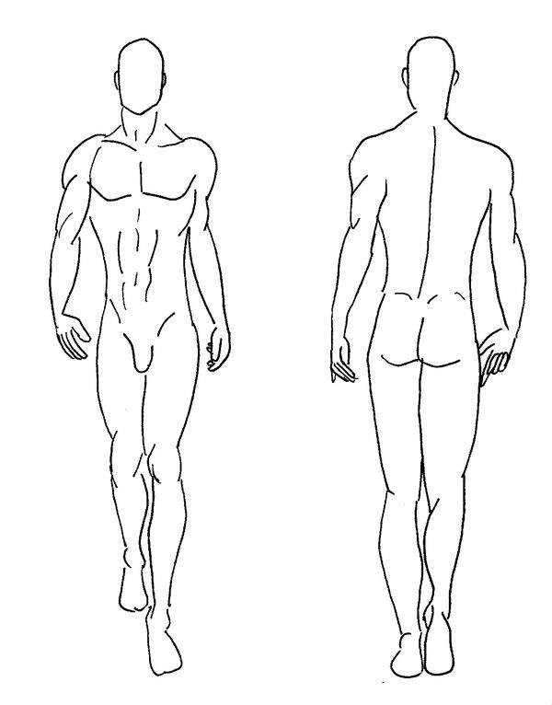



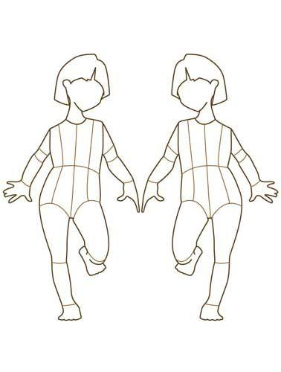

**YEAST DONUTS**

**INGREDIENTS**

* **1 tbsp quick rising yeast**
* **½ cup lukewarm**[**water**](http://www.geniuskitchen.com/about/water-459)
* **1 ½ tablespoons**[**sugar**](http://www.geniuskitchen.com/about/sugar-139)
* **1** [**egg**](http://www.geniuskitchen.com/about/egg-142)**, well beaten**
* **1⁄4 teaspoon**[**cinnamon**](http://www.geniuskitchen.com/about/cinnamon-324)
* **1⁄4 cup melted**[**butter**](http://www.geniuskitchen.com/about/butter-141)
* **1 teaspoon**[**vanilla**](http://www.geniuskitchen.com/about/vanilla-350)
* **½ teaspoon**[**salt**](http://www.geniuskitchen.com/about/salt-359)
* **1 ¼ cups**[**flour**](http://www.geniuskitchen.com/about/flour-64)**(use More if too sticky)**
* **cooking oil (for frying)**

**DIRECTIONS**

1. Mix yeast, water and sugar.
2. Wait until bubbles form in mixture.
3. Add egg, butter, cinnamon, vanilla, salt and flour.
4. Mix to form dough.
5. Knead dough for 1 minute.
6. Roll out and cut out donuts.
7. Allow to rise for 30 minutes on floured surface.
8. Fry in oil until golden brown. Oil should be approximately 375°F. Place on paper towel to drain and cool.
9. Coat in cinnamon & sugar mixture or your favorite topping.
10. These freeze very well after they have fully cooled, if there are any left.
11. Leave oil in large pot and move off burner to cool.

Adapted From: <http://www.geniuskitchen.com/recipe/incredible-easy-raised-donuts-203062>

Baked Doughnuts Three Ways

PREP 5 mins. to 17 mins.

BAKE 10 mins. to 10 mins.

TOTAL 25 mins. to 27 mins.

YIELD 12 doughnuts

Old-fashioned cake doughnuts were deep-fried in hot fat; NEW-fashioned cake doughnuts are baked in a hot oven! Use a doughnut pan and this tasty recipe to create your choice of doughnuts.

* 1/4 cup (4 tablespoons) butter
* 1/4 cup vegetable oil
* 1/2 cup granulated sugar
* 1/3 cup brown sugar
* 2 large eggs
* 1 1/2 teaspoons baking powder
* 1/4 teaspoon baking soda
* 1/2 to 1 teaspoon ground nutmeg, to taste
* 3/4 teaspoon salt
* 1 teaspoon [vanilla extract](https://www.kingarthurflour.com/recipes/detail.jsp?id=1842)
* 2 2/3 cups [King Arthur Unbleached All-Purpose Flour](https://www.kingarthurflour.com/recipes/detail.jsp?id=3005)
* 1 cup milk

## **Directions**

1. Preheat the oven to 425°F. Lightly grease two [standard doughnut pans.](https://www.kingarthurflour.com/shop/landing.jsp?go=DetailDefault&id=5233)
2. In a medium-sized mixing bowl, beat together the butter, vegetable oil, and sugars until smooth.
3. Add the eggs, beating to combine.
4. Stir in the baking powder, baking soda, nutmeg, salt, and vanilla.
5. Stir the flour into the butter mixture alternately with the milk, beginning and ending with the flour and making sure everything is thoroughly combined. The batter will be fairly thick; when you draw your spatula through the batter, it will leave a furrow.
6. Spoon the batter into the lightly greased doughnut pans, filling the wells to about 1/4" shy of the rim.
7. Bake the doughnuts for 10 minutes. Remove them from the oven, and wait 5 to 7 minutes before turning them out of the pans onto a rack.
8. For cinnamon doughnuts, shake warm doughnuts in a plastic bag with about 1/4 to 1/3 cup cinnamon-sugar. For sugar-coated doughnuts, shake doughnuts in a plastic bag with about 1/2 cup [non-melting topping sugar](https://www.kingarthurflour.com/shop/landing.jsp?go=DetailDefault&id=1307)(for best results), or confectioners' sugar.
9. For frosted doughnuts, see our [three easy doughnut glazes.](http://www.kingarthurflour.com/recipes/three-easy-doughnut-glazes-recipe) Sprinkle the glazed doughnuts with toasted coconut or chopped nuts, if desired.

<https://www.kingarthurflour.com/recipes/PrintRecipe?RID=4037&radio=1>

**Loaded Baked Potato Salad**

**Yield: 4 servings**

Ingredients

3 russet bakers’ potatoes, skin on, washed (chopped into small cubes)

Splash of oil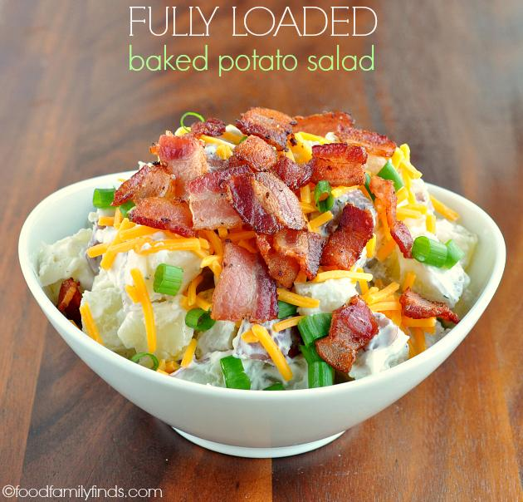

Sprinkle of seasoning salt

¾ cup sour cream  
1/4 cup mayonnaise  
 splash of white vinegar (optional)   
black pepper to taste /other seasoning  
  
3 slices bacon, cooked and crumbled

1 green onion, sliced thin

½ cup grated cheddar cheese

Directions

1. Preheat oven to 450F.

2. Cut potatoes into small cubes, toss in oil. Place on baking sheet and sprinkle with seasoning salt. (Put in oven even if it is not fully preheated). Watch and turn every 10 minutes. Cook until golden brown about 30-40 minutes.

3. Fry bacon in a large nonstick frying pan; remove to paper towel lined plate to drain. *Caution Hot*  
  
4. Remove potatoes from the oven, place in a serving bowl toss in sour cream and mayonnaise.

5. Top with cheese, green onions, and bacon.

6. Serve warm and enjoy!

[**Baked Spinach & Artichoke Dip**](http://www.cbc.ca/inthekitchen/2012/12/baked-spinach-artichoke-dip.html)

<http://www.cbc.ca/inthekitchen/2012/12/baked-spinach-artichoke-dip.html>

Always the first to go at a party, this indulgent baked dip is creamy, cheesy and irresistible!

**INGREDIENTS**

butter, for greasing the baking dish

½ pkg frozen chopped (thaw in microwave) remove as much moisture as you can

¼ cup mayonnaise  
¼ cup sour cream  
½ package cream cheese, room temperature  
1 tbsp lemon juice 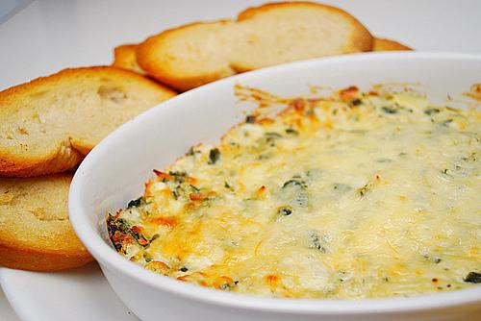

½ can artichokes (4 pieces), rinsed, drained and chopped small  
¼ cup grated parmesan cheese

½ cup grated mozzarella cheese  
1-2 garlic cloves, finely chopped  
Pinch cayenne, to taste  
Salt and freshly ground pepper, to taste

ADD ½ can flaked crab meat (optional)

Serve with Chips

**PREPARATION**

1. Preheat oven to 375 degrees F. Butter small baking dish.
2. Add cream cheese, mayonnaise, sour cream and lemon juice to a medium bowl. Beat with electric beaters until smooth.
3. Stir in chopped artichokes, spinach, parmesan & mozzarella cheese, garlic, cayenne, and salt and pepper. FOLD IN crab.
4. Transfer to small baking dish. Bake dip until bubbly and hot, and lightly golden brown on top, about 15 to 20 minutes.
5. Serve with chips

Yield: 4 servings.

**Banana Muffins**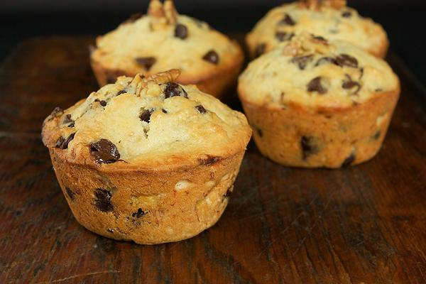

By The Canadian Living Test Kitchen

**Ingredients**

* 1 ¼  cups [all-purpose flour](http://www.canadianliving.com/glossary/all_purpose_flour.php)
* ½  cup packed [brown sugar](http://www.canadianliving.com/glossary/brown_sugar.php)
* ¾  tsp [baking powder](http://www.canadianliving.com/glossary/baking_powder.php)
* ½  tsp [baking soda](http://www.canadianliving.com/glossary/baking_soda.php)
* ¼  tsp [salt](http://www.canadianliving.com/glossary/salt.php)
* 1  [eggs](http://www.canadianliving.com/glossary/egg.php)
* ½  cup [buttermilk](http://www.canadianliving.com/glossary/buttermilk.php)
* ½  cup mashed [bananas](http://www.canadianliving.com/glossary/banana.php) (1 small banana)
* 1/3 cup [vegetable oil](http://www.canadianliving.com/glossary/vegetable_oil.php)
* ½  tsp [vanilla](http://www.canadianliving.com/glossary/vanilla.php)
* ½  cup [chocolate](http://www.canadianliving.com/glossary/chocolate.php) [chips](http://www.canadianliving.com/glossary/chips.php) or raspberries or mixed fruit

**Preparation**

1. In large bowl, whisk together flour, sugar, baking powder, baking soda and salt.
2. In separate bowl, beat eggs; blend in buttermilk, bananas, oil and vanilla.
3. Pour over dry ingredients. Sprinkle with chocolate chips; stir just until dry ingredients are moistened.
4. Spoon into greased or paper-lined muffin cups, filling three-quarters (3/4) full.
5. Bake in centre of 375°F (190°C) oven until tops are firm to the touch, 20 to 25 minutes.
6. Let cool in pan on rack for 5 minutes; transfer to rack and let cool.

**Bruschetta**

**Ingredients:**

1/4 cup Mayonnaise (Add a little ranch too optional)

1/2 cup mozzarella cheese

1 tomato, diced

1 Tbsp dried parmesan

½ tsp oregano

1/8 tsp basil

¼ tsp pepper

Half loaf of baguette bread

**Directions:**

1. Combine first 7 ingredients in a small bowl.
2. Cut baguette into 1 inch slices.
3. Place on un-greased baking sheet.
4. Divide and spread tomato mixture on bread slices.
5. Bake in 350 oven for 10 minutes OR until hot and cheese is melted.

Serve warm.

Makes about 12

**Croque Monsieur**

**Ingredients**

* 2 tbsp (30 mL) Dijon mustard (optional) use mayo
* 8 thick (1/2-inch/1 cm) slices multigrain bread
* 4 slices Gruyère cheese (mozza/cheddar)
* 4 thin slices ham
* 2 tbsp (30 mL) butter
* 1 tsp (5 mL) vegetable oil
* 1 cup (250 mL) shredded Gruyère cheese (cheddar/mozza/parmesan )

**Béchamel:**

* 1 tbsp (15 mL) butter
* 1 tbsp (15 mL) all-purpose flour
* 1 cup (250 mL) milk
* 1 pinch nutmeg
* 1 pinch salt
* 1 pinch pepper

**Preparation**

**Move oven rack to 2nd top position and turn on the broiler.

**Béchamel:** In small saucepan, melt butter over medium heat; add flour and cook, whisking constantly, for 1 minute. Whisk in milk and bring to boil; reduce heat and simmer, whisking, until thickened, about 3 minutes. Stir in nutmeg, salt and pepper. Set aside.  
  
**Sandwiches:** Butter one side of each slice of bread. Spread mustard (or mayo) on the other side ; top each with 1 slice each Gruyère (mozza/cheddar) cheese and ham. Top with remaining bread. Heat large skillet over medium heat. Cook sandwiches until golden, about 3 minutes per side. Transfer into a small cake pan lightly greased with oil (use cooking oil and paper towel) place in sandwiches.   
Pour béchamel onto sandwiches, without dripping down sides; sprinkle with shredded Gruyère cheddar, mozza, parmesan) cheese. Broil until cheese is melted and light golden, 2 to 4 minutes.

**Meat, Poultry and Alternatives**

What is protein?

What are some food choices that are considered a source of protein for breakfast, lunch and dinner?

Breakfast –

Lunch –

Dinner –

Are you or anyone you know a vegetarian? If so, who?

**BEEF**

Go to the website [www.cabprogram.com/cab/food/cuts.html](http://www.cabprogram.com/cab/food/cuts.html) (Cattlemen’s Beed Association).

Using your attached worksheet identify five cuts of meat, where they come from on the cow, and a brief description of how that cut of meat could be cooked (NOT just the term – explain it).

**PORK**

Go to the website [www.pork.org/cooking/cuts/](http://www.pork.org/cooking/cuts/) (National Pork Board).

Using your attached worksheet identify five cuts of meat, where they come from on the pig, and a brief description of how that cut of meat could be cooked (NOT just the term – explain it).

**CHICKEN**

You can purchase chicken in parts or whole depending on your preference.

List as many parts of the chicken as you can…

What is your favorite part of the chicken?

When you look at the chicken chart below, what similarities do you see compared to the beef and pork charts?

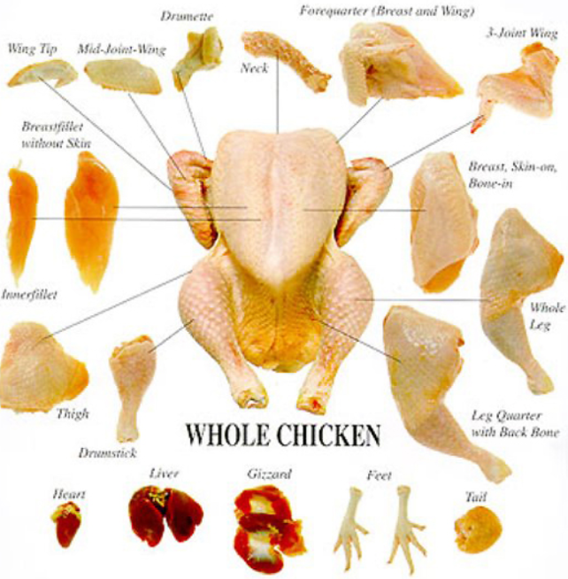

What other types of meat have you heard of? List as many as you can.

**FISH**

What is the difference between shellfish and other types of fish?

Do you have a favorite?

**VEGETARIAN**

Not eating meat and fish is an option. Here is why!

Go to the website [www.vrg.org/nutrition/teennutrition.htm](http://www.vrg.org/nutrition/teennutrition.htm) (Vegetarian Resource Group).

While reading the section on teen nutrition, discuss 5 points about the vegetarian life-style.

1)

2)

3)

4)

5)

While reading this section identify 5 items that are protein alternatives for meat or fish.

1)

2)

3)

4)

5)

There are many types of vegetarians. Some eat dairy foods, such as cheese or eggs, while others abstain entirely from any food product that comes from an animal.

Using the following websites list the most common types (7) of vegetarians. Also give a brief explanation of what their diet looks like along with any impacts or benefits that come along with the diet. I gave you hints as to which ones I’d like you to learn more about.

<https://vegetarian-nation.com/resources/common-questions/types-levels-vegetarian/>

<https://www.care2.com/causes/7-types-of-vegetarianism-and-their-environmental-and-health-benefits.html>

<https://www.ivyroses.com/HumanBiology/Nutrition/types-of-vegetarians.php>

1. V_________

Diet –

Impacts/Benefits –

1. L_____ V___________

Diet –

Impacts/Benefits –

1. O___ V___________

Diet –

Impacts/Benefits –

1. L_____-O___ V___________

Diet –

Impacts/Benefits –

1. P_____________

Diet –

Impacts/Benefits –

1. P____________

Diet –

Impacts/Benefits –

1. F___________

Diet –

Impacts/Benefits –